Connecting using an SSH client on Windows

There are many free and commercial SSH client programs available for Windows. A good, popular free client is [PuTTY](http://www.chiark.greenend.org.uk/~sgtatham/putty/). To use it, simply [download the putty.exe file](http://www.chiark.greenend.org.uk/~sgtatham/putty/download.html), then double-click putty.exe on your computer to run it. You'll see PuTTY's configuration dialog appear:

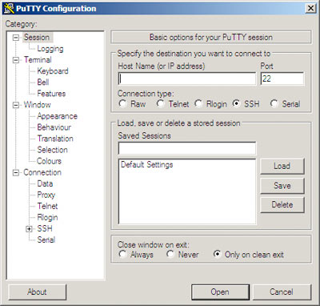

Enter your Web server's IP address or hostname in the Host Name (or IP address)box, and click Open. The first time you connect to your Web server, you'll probably see a security alert dialog appear, warning you that PuTTY doesn't know anything about the machine ("host") that you're connecting to. Click Yes to add your server to PuTTY's cache and proceed with the connection.

You'll now see a black terminal window appear, containing a "login as:" prompt:

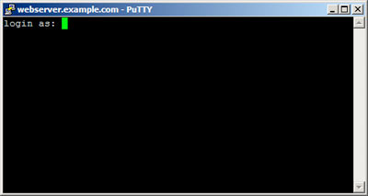

Enter your username, and press Enter. A "Password:" prompt appears; enter your password and, again, press Enter. If all goes well, you'll now be logged into your Web server. You'll probably see some sort of welcome message from your server, followed by a shell prompt:

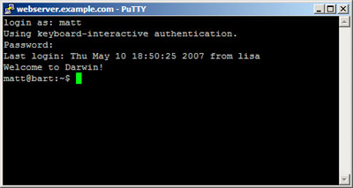

Connecting using an SSH client on Linux

Once you have a terminal window open (ctrl+alt+t)(hot key for Ubuntu), type:

**ssh username@hostname**

where username is your SSH username, and hostname is the host name or IP address of your Web server. Then press Enter. If this is the first time you've tried to connect to this computer, you'll see a warning to the effect that the host couldn't be authenticated. Type yes and press Enter to confirm that you'd like to continue with the connection.

After a few seconds you should see a "Password:" prompt appear; enter your password and press Enter once again. You should now see a welcome message and a shell prompt, indicating that you're logged into your Web server:

**Type “hostname”** username ”

**Type “your username”** username ”

Type “ssh”

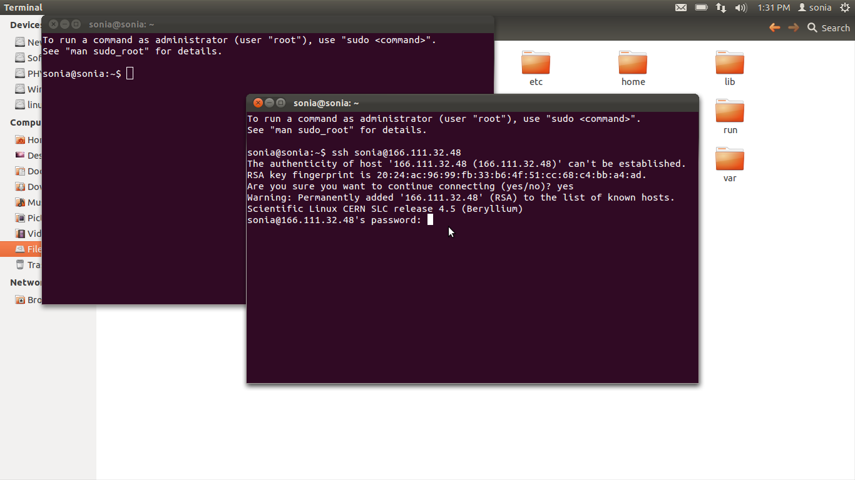

**Type “your password”**

**Type “yes”**